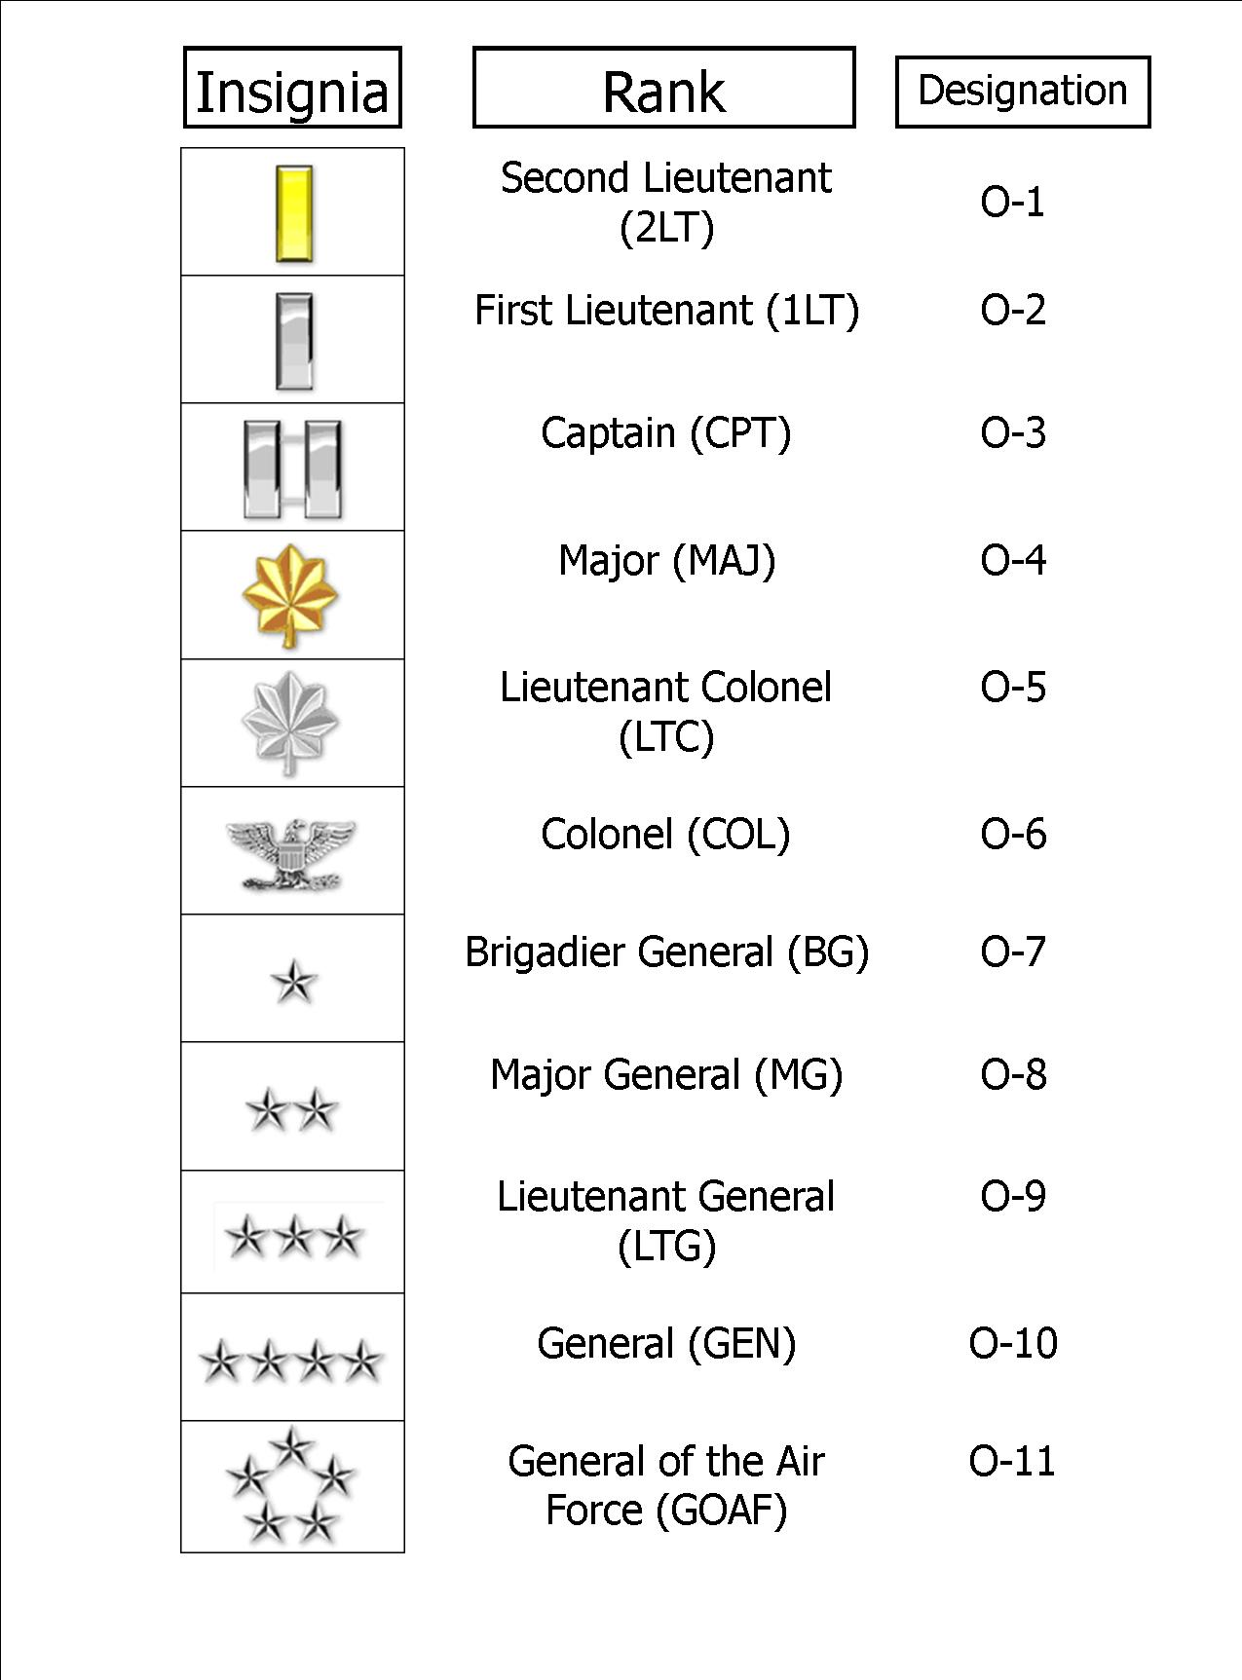

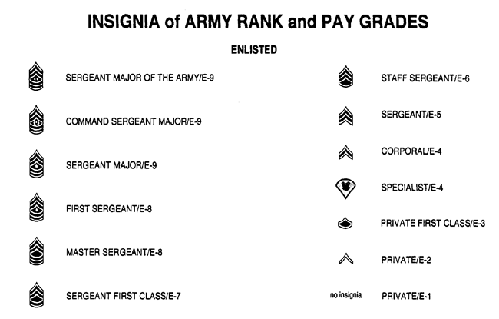
California:
State Birthday: Sept. 9, 1850
When admitted into the union, what number was the state? 31st state
State Capital: Sacramento
State Nickname: The Golden State
State Bird: California Valley Quail
State Flower: California Poppy
State Motto: “Eureka” (I have found it)
State Colors:
Blue- Represents the sky and sea
Gold- Symoblizes the color of the precious mineral mined by the forty-niners from the hills of California

State Flag:
1. Grizzly Bear- Represents Strength
2. Red Star- Nod to the Republic of Texas
3. Red Stripe- Forms the Length

Army Knowledge:
Army Motto: “Army Strong”
How many belt loops are on the trousers and what do they represent? Seven, Represent the
7 seas

Leadership Principles:
1.Be technically and tactically proficient.
2.Know yourself and seek self-improvement.
3.Know your men and look out for their welfare.
4.Keep your men informed.
5.Set the example.
6.Insure that the task is understood, supervised, and accomplished.
7. Train your men as a team.
8. Make sound and timely decisions.
9. Develop a sense of responsibility among subordinates.
10. Employ your command in accordance with its capabilities.
11. Seek responsibility and take responsibility for your actions.

